European Radio Show 2017:
Meet the top of British radio industry in one place!

Exceptional! The "Big Four" of British radio - BBC, Global, Bauer and Wireless - will open the European Radio Show at the end of January in Paris. The event will welcome the UK as featured country for three days on 29, 30 and 31 January 2017. Almost a hundred conferences and more than 100 exhibitors are convened to the only free European event dedicated to radio. Discover in exclusivity the names of the main European radio executives that will attend the event and interact during the show. You are a radio professional? Sign up now to attend the event, it's FREE and places are filling up quickly! www.europeanradioshow.com

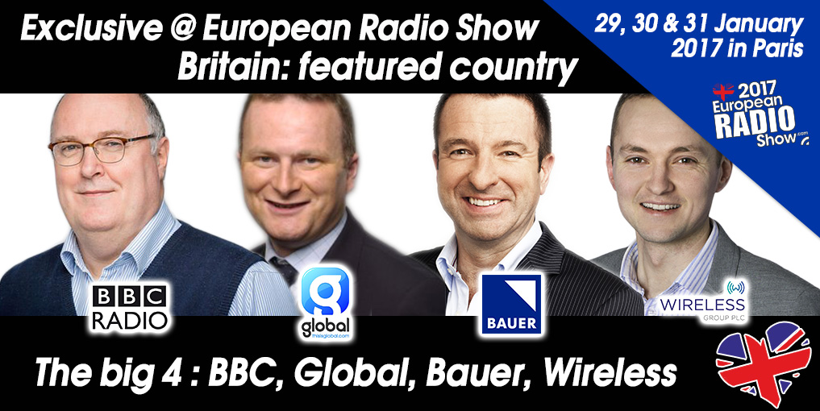

The show will open on Sunday 29th January at 11am with an exceptional panel of speakers from the UK: Ian O’Neill (UK Department for Culture, Media and Sport), Alan Davey (BBC), Will Harding (Global), Steve Parkinson (Bauer), Vanessa Messad (Wireless Group), Ford Ennals (Digital Radio UK), and Dom Chambers (Community radios).

Other European speakers attending the three day show are: Jimmy Buckland (Wireless Group), Matt Deegan (Fun Kids), Jerry Hill (RAJAR), Michael Hill (RadioPlayer), Miles Palmer (TuneIn), Mark Barber (RadioCentre), Judith Spilsbury (RadioCentre), Yuri Loburets (EGTA), Vincent Sneed (AER), Mark Friend (BBC), Elizabeth Lane (BBC), Will Jackson (RIG, RadioToday), Megan Lazovick (Edison Research), Jean-Marc Dubreuil (WorldDAB), Jonathan Arendt (Jazz FM), Jørn Jensen (NRK), Marcel Regnotto (Ofcom, Switzerland), Carsten Zorger (Digitalradio Büro Deutschland), Jacqueline Bierhorst (Digital Radio Netherlands), Francis Currie (Currie Nordén Research), Denis Florent (Radio Format), Darryl von Däniken (IRF), Graham Dixon (EBU-UER), Alain Artero (.radio).

LIST OF THE MAIN CONFERENCES DEDICATED TO THE UNITED KINGDOM AND EUROPE
Sunday 29 January 2017 - 11am to 12.30pm
Opening Conference - UK: Radio is in the future
UK Department for Communication – Ian O'Neill OBE
BBC Radio – Alan Davey
Global – Will Harding
Bauer – Steve Parkinson
Wireless Group – Vanessa Messad
Community radios – Dom Chambers
Digital Radio UK – Ford Ennals

Sunday 29 January 2017 – 2pm to 3pm
How to attract millennials?
Edison Research – Megan Lazovick
FunKids – Matt Deegan
Bauer – Kiss – Steve Parkinson
BBC Radio – Mark Friend and Elizabeth Lane

Sunday 29 January 2017 – 3pm to 4pm
The genuine dot radio extension
EBU-UER – Alain Artero
EBU-UER – Graham Dixon

Sunday 29 January 2017 - 4.30pm to 5.30pm
Community radio and local contents in the UK and Europe
Community Radios – Dom Chambers
RIG – Will Jackson
BBC, AIRPI, LAMARC – To be confirmed

Monday 30 January 2017 – 11.00am to 12.30pm:
Audio and Advertising Research & Regulatory challenges for radio in Europe
EGTA – Yuri Loburets
Radio Centre – Mark Barber
AER – Vincent Sneed
Radio Centre – Judith Spilsbury

Monday 30 January – 12.15pm:
KeyNote – Morning Show Secrets
Radio Format – Denis Florent
Currie Nordén – Francis Currie
Currie Nordén – Niklas Nordén

Monday 30 January – 1pm to 2.30pm:
Recipes of radio portals for smartphones and cars
RadioPlayer – Michael Hill
TuneIn – Miles Palmer
Les Indés Radios – Yann Legarson
BBC – BBC iPlayer – Mark Friend

Monday 30 January 2017 – 2.30pm to 3.30pm:
Future of radio listening measurement in Europe
RAJAR – Jerry Hill
Médiamétrie – Aurélie Fau

Monday 30 January 2017 – 2.30pm to 3.30pm:
New vision for content – Is audio push one key?
International Radio Festival – Darryl von Däniken
Konsole Labs – Maximilian Knop

Tuesday 31 January 2017 - 10am to 11am:
Sport and Radio in Europe
Wireless Group / TalkSport – Vanessa Messad
RMC – François Giuseppi

Tuesday 31 January 2017 – 11am to 1pm:
Digital Radio in UK and Europe
France: J-E Valli, Président, Les Indés Radios
France: Jean-Marc Dubreuil, WorldDAB (France)
UK: Jimmy Buckland from Wireless Group
UK: Jonathan Arendt from Jazz FM
Norway: Jørn Jensen from NRK
Switzerland: Marcel Regnotto, Ofcom
Germany: Carsten Zorger, Digitalradio Büro Deutschland
Netherlands: Jacqueline Bierhorst from Digital Radio Netherlands

THE OTHER EVENTS OF THE SHOW
- Sunday: Launch of the .radio internet domain by EBU
- Sunday: ON'R BRANDY Awards - Radio of the Year
- Sunday: RADIOPUB Awards
- Monday: Radio 2.0
- Monday: Late opening and showcase with Corson & Emma Daumas
- Tuesday: WorldDAB conference

FULL PROGRAMME AND FREE REGISTRATION
Go to the website:
www.europeanradioshow.com

- Nearly hundred conferences, roundtables and keynotes speeches for 3 days in English and French in 5 rooms.
- More than 100 exhibitors on 4,000 square meters
- Free access to the exhibition hall and to all conference rooms during the three days (except Radio 2.0) – online pre-registration required.

